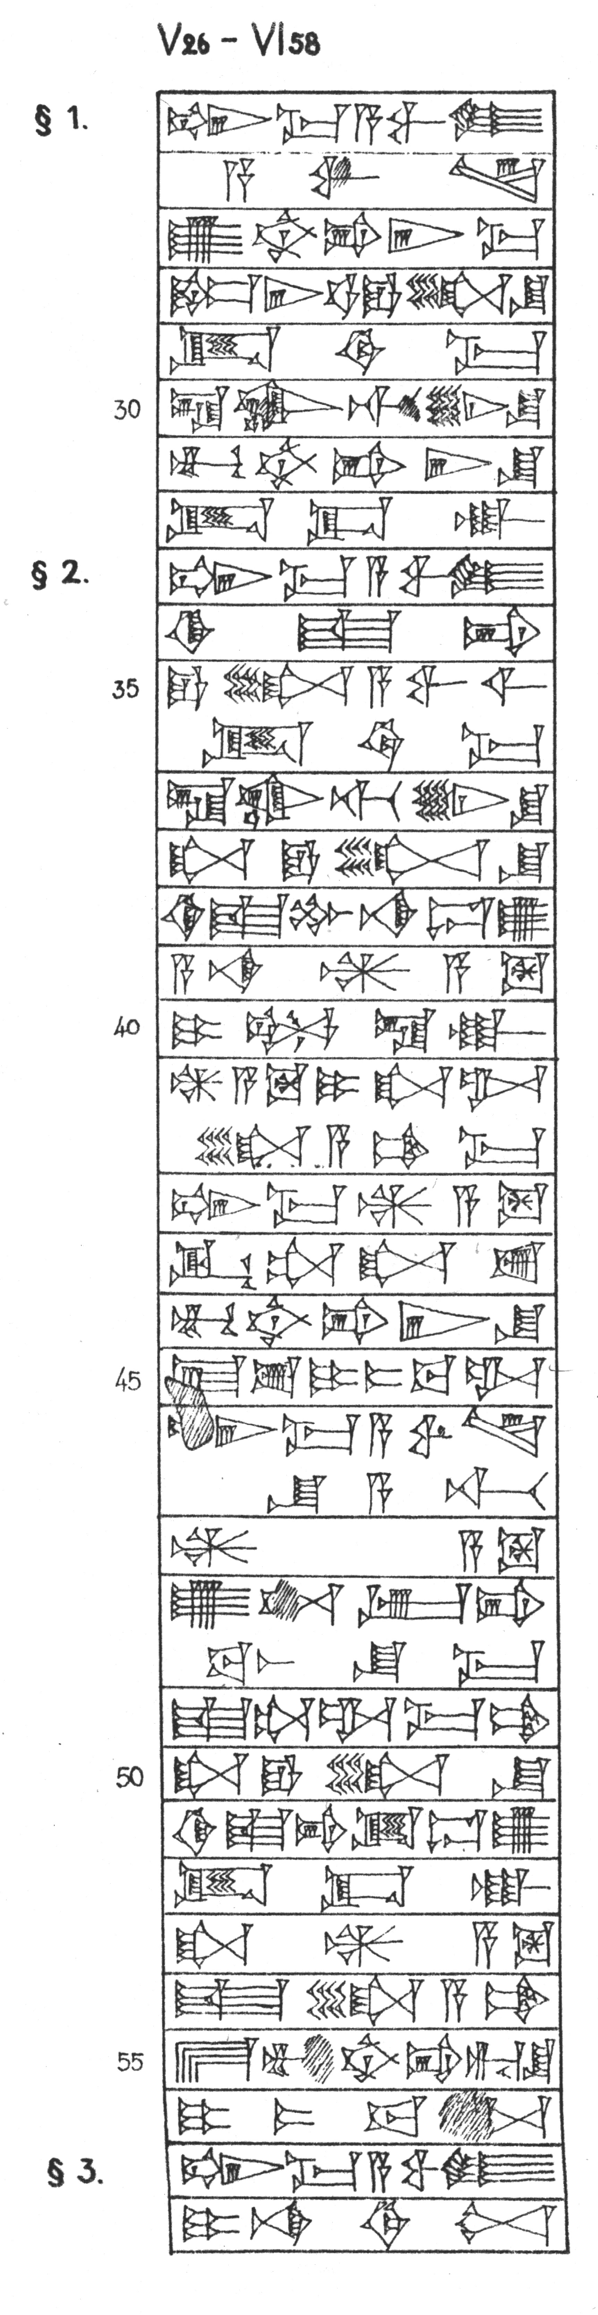 | V  26 | šum-ma a-wi-lum | šumma awīlum | §1
 |  | a-wi-lam | awīlam
 | 27 | ú-ub-bi-ir-ma | ubbirma
 | 28 | ne-er-tam e-li-šu | nērtam elīšu
 | 29 | id-di-ma | iddima
 | 30 | la uk-ti-in-šu | lā uktīnšu
 | 31 | mu-ub-bi-ir-šu | mubbiršu
 | 32 | id-da-ak | iddâk
 | 33 | šum-ma a-wi-lum | šumma awīlum | §2
 | 34 | ki-iš-pí | kišpī
 | 35 | e-li a-wi-lim | eli awīlim
 |  | id-di-ma | iddima
 | 36 | la uk-ti-in-šu | lā uktīnšu
 | 37 | ša e-li-šu | ša elīšu
 | 38 | ki-iš-pu na-du-ú | kišpū nadû
 | 39 | a-na ^{d}ÍD | ana nārim
 | V  40 | i-il-la-ak | illak
 | 41 | ^{d}ÍD i-ša-al- | nāram išalliamma
 |  | -li-a-am-ma
 | 42 | šum-ma ^{d}ÍD | šumma nārum
 | 43 | ik-ta-ša-sú | iktašassu
 | 44 | mu-ub-bi-ir-šu | mubbiršu
 | 45 | É-sú i-tab-ba-al | bīssu ittabbal
 | 46 | š[u]m-ma a-wi-lam | šumma awīlam
 |  | šu-a-ti | šuāti
 | 47 | ^{d}ÍD | nārum
 | 48 | ú-te-eb-bi- | utebbibaššuma
 |  | -ba-aš-šu-ma
 | 49 | iš-ta-al-ma-am | ištalmam
 | 50 | ša e-li-šu | ša elīšu
 | 51 | ki-iš-pí id-du-ú | kišpī iddû
 | 52 | id-da-ak | iddâk
 | V  53 | ša ^{d}ÍD | ša nārum
 | 54 | iš-li-a-am | išliam
 | 55 | É mu-ub-bi-ri-šu | bīt mubbirīšu
 | 56 | i-tab-ba-al | ittabbal
 | 57 | šum-ma a-wi-lum | šumma awīlum | §3
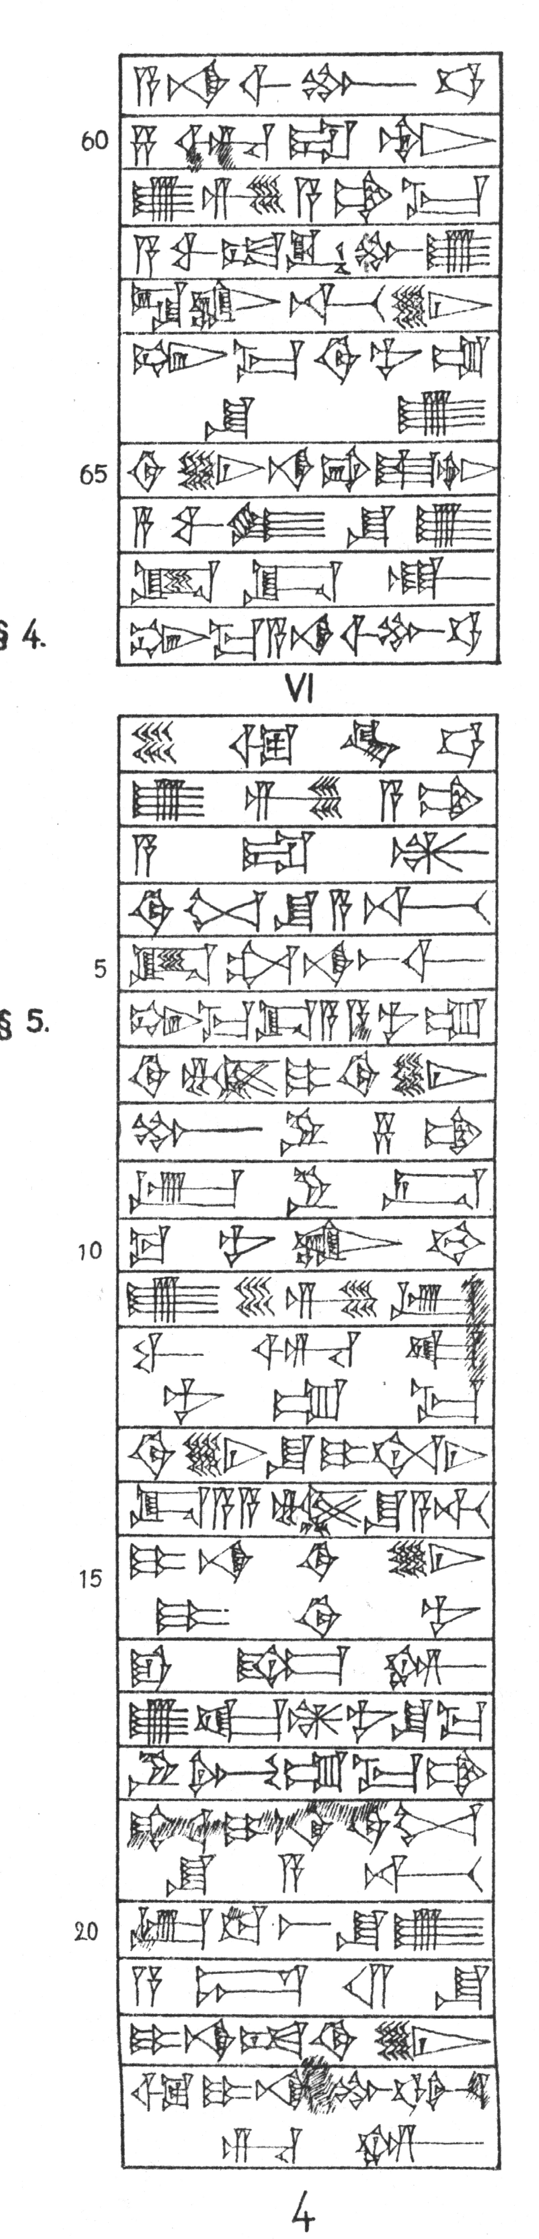 | 58 | i-na di-nim | ina dīnim
 | 59 | a-na ši-bu-ut | ana šibūt
 | 60 | sà-ar-ra-tim | sarrātim
 | 61 | ú-ṣí-a-am-ma | ūṣiamma
 | 62 | a-wa-at iq-bu-ú | awāt iqbû
 | 63 | la uk-ti-in | lā uktīn
 | 64 | šum-ma di-nu-um | šumma dīnum
 |  | šu-ú | šū
 | 65 | di-in na-pí-iš-tim | dīn napištim
 | 66 | a-wi-lum šu-ú | awīlum šū
 | 67 | id-da-ak | iddâk
 | V  68 | šum-ma a-na ši-bu-ut | šumma ana šibūt | §4
 | VI  1 | ŠE ù KÙ.BABBAR | šeʾim ū kaspim
 | 2 | ú-ṣí-a-am | ūṣiam
 | 3 | a-ra-an | aran
 | 4 | di-nim šu-a-ti | dīnim šuāti
 | 5 | it-ta-na-aš-ši | ittanašši
 | 6 | šum-ma da-a-a-nu-um | šumma dayyānum | §5
 | 7 | di-nam i-di-in | dīnam idīn
 | 8 | pu-ru-sà-am | purussâm
 | 9 | ip-ru-ús | iprus
 | 10 | ku-nu-uk-kam | kunukkam
 | 11 | ú-še-zi-ib | ušēzib
 | 12 | wa-ar-ka- | warkānumma
 |  | -nu-um-ma
 | 13 | di-in-šu i-te-ni | dīnšu īteni
 | 14 | da-a-a-nam šu-a-ti | dayyānam šuāti

